Launch of First Butterfly Care Homes in Canada
Person-Centered Care and Dementia Guru Dr. David Sheard , founder of U.K’s renowned Butterfly homes came to Alberta a few years ago introducing Dementia Care Matters, the national movement in dementia Care in U.K. In October 2014, Dr. Sheard came back and the community, leaders in Health, and the public media listened to him talk of his passionate and uncompromising stance in dementia care.
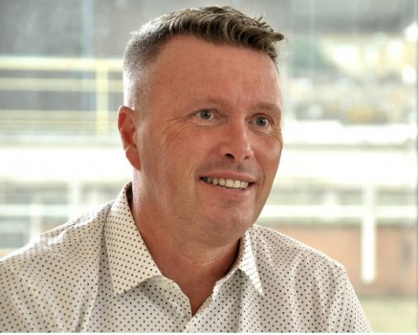

Dr. David Sheard (in photo)
In 2014 Dr. Sheard received the award of UK Care Personality of the Year, with the judging panel noting his “beliefs, values, boundless energy and passion have driven changes that to many were only a dream.”
Dr. Sheard’s proposition is that quality dementia care needs to be measured in terms of peoples lived experience. He maintains that a domestic scale approach similar to the homes household we all live in, brings out the best in people living with a dementia and that continuing care homes can be split into households. Dr. Sheard’s cites data showing that in one Butterfly Care home the use of neuroleptic drugs was reduced from 70 occasions to just one, over a six-month period.

Speaking to the audience last October 2014 in his speaking tour in Canada, Dr. Sheard said he set out with a philosophy that “feelings matter most” and a core belief that people living with a dementia are more feeling beings than thinking beings.

Dr. David Sheard’s talk moved a lot of people in the audience including Renate Sainbury, General Manager of Lifestyle Options Retirement Communities.

Renate shares statistics that, one in five Canadians aged 45 and older provides some form of care to seniors living with long-term health problems. In 2011, 747,000 Canadians were living with Alzheimer’s disease and other dementias - that's 14.9 per cent of Canadians 65 and older. The numbers are frightening, says Renate Sainsbury, who also sits as a member in the Provincial Committee for Dementia Strategy. What’s even more concerning is, as a community, we have a quite a long way to go in the way we approach Dementia Care, says Renate. Renate knew she just had to do something. She states, “It’s the right thing to do.”
From October 2014 to April 2015, there were numerous corresponding emails and teleconference between Dr. Sheard and Renate. Finally, In June 2015, the agreement was finalized and Butterfly Homes will be piloted in Edmonton. Dr. David Sheard will launch 3 Butterfly home pilot sites in Alberta, Canada with one of them at Renate’s managed Retirement Home at Lifestyle Options Whitemud.
Quoting Dr. David Sheard’s touching words, he said: “When you can no longer rely on facts, logic, reason or memory, it is your feelings and emotional truth that you trust.”

Launching of the Butterfly Home Pilot Project by Dr. David Sheard will be in July 2015. For more
information of this project launch, please email rsainsbury@lifestyleoptions.ca and for information of Dr. David Sheard, Please check his website www.dementiacarematters.com

Eldercare: What we know Today. (2008) Statistics Canada
A new way of looking at the impact of Dementia in Canada. Alzheimer Society , 2012

